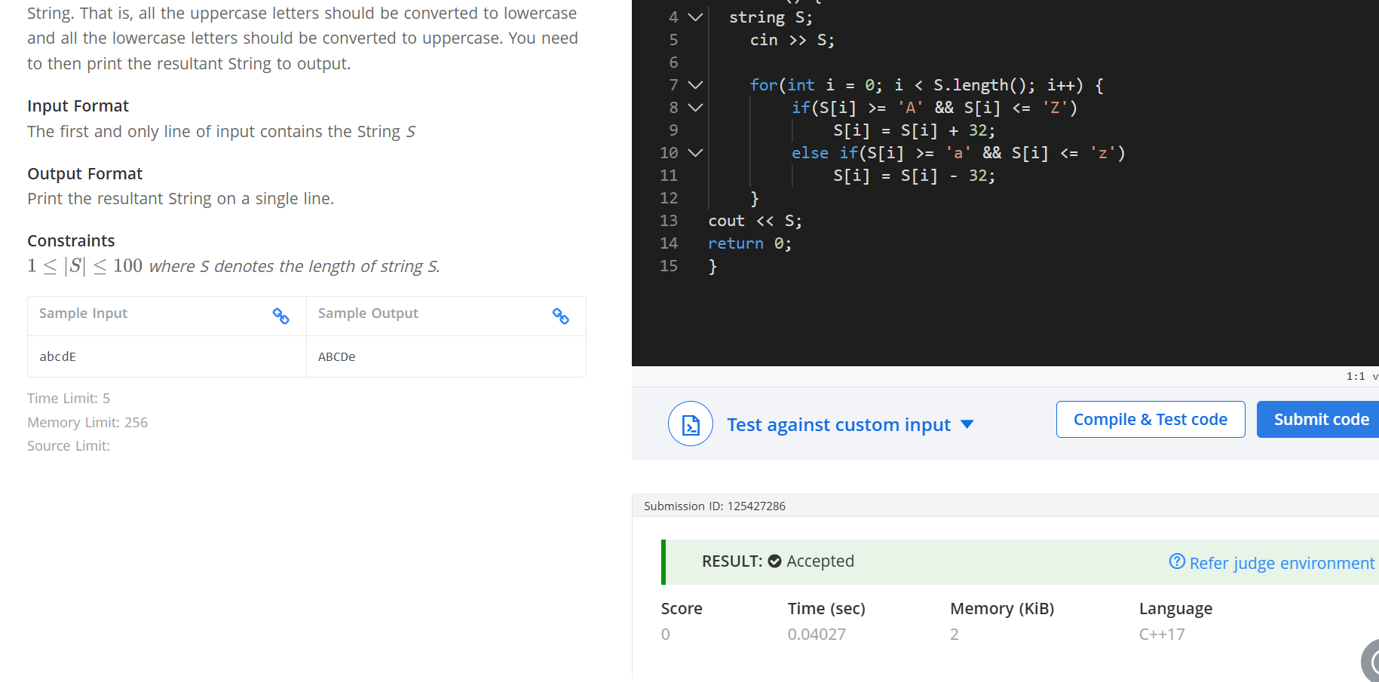
Q Toggle string
#include <iostream>
using namespace std;
int main() {
string S;
cin >> S;

for(int i = 0; i < S.length(); i++) {
if(S[i] >= 'A' && S[i] <= 'Z'
S[i] = S[i] + 32;
else if(S[i] >= 'a' && S[i] <= 'z')
S[i] = S[i] - 32;
}
cout << S;
return 0;
}

